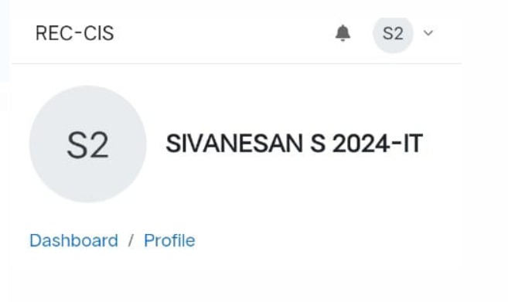

1. Problem Statement

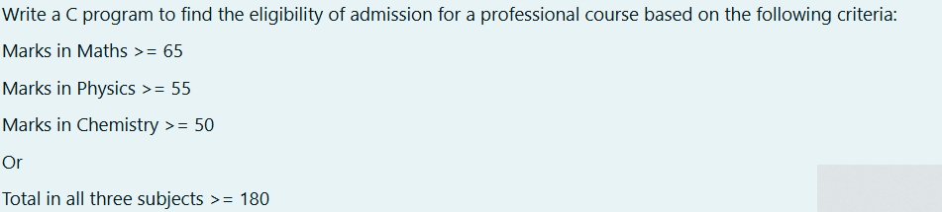

CODING

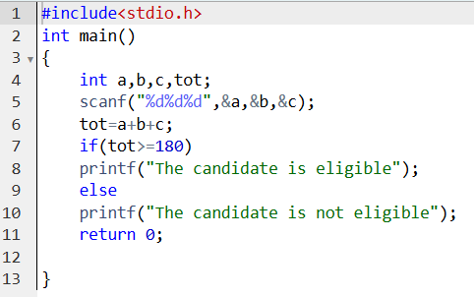

**OUTPUT**

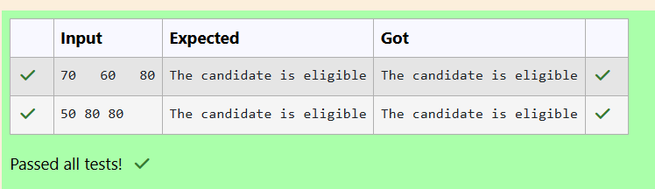

1. PROBLEM STATEMENT



CODING

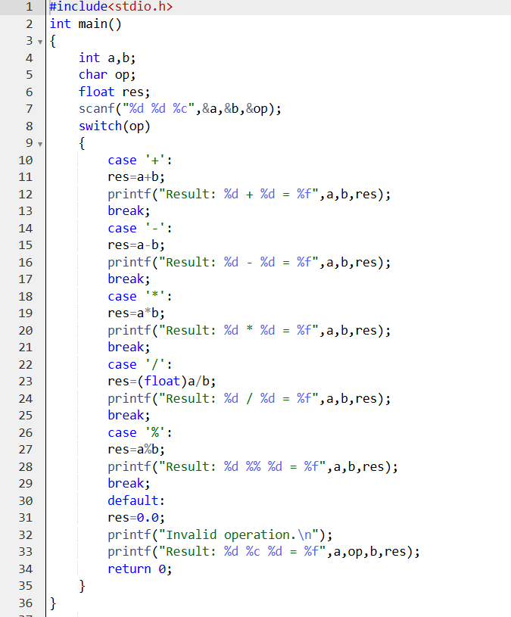

OUTPUT

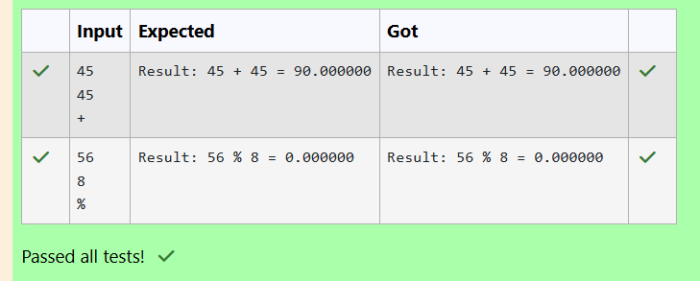

1. PROBLEM STATEMENT

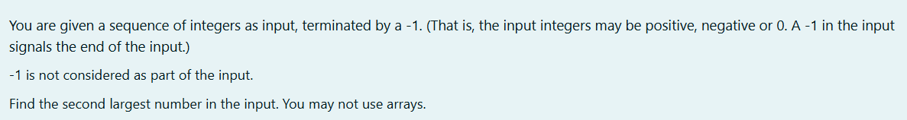

**CODING**

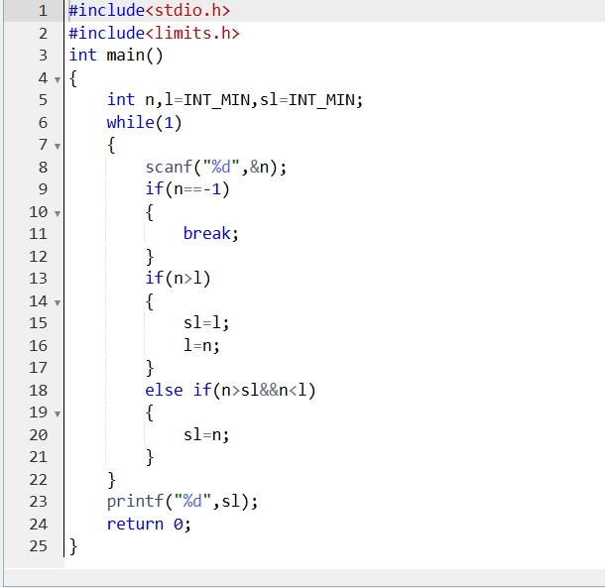 **OUTPUT**

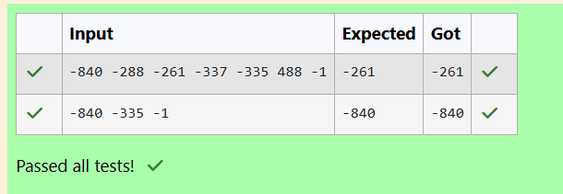

**4.PROBLEM STATEMENT**



**CODING**

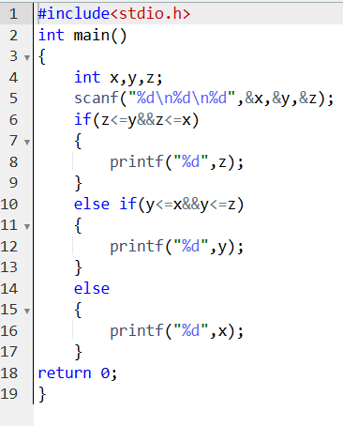

**OUTPUT**

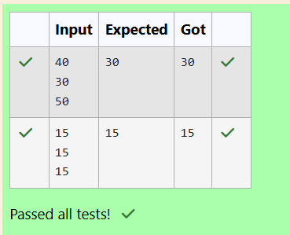

1. **PROBLEM STATEMENT**

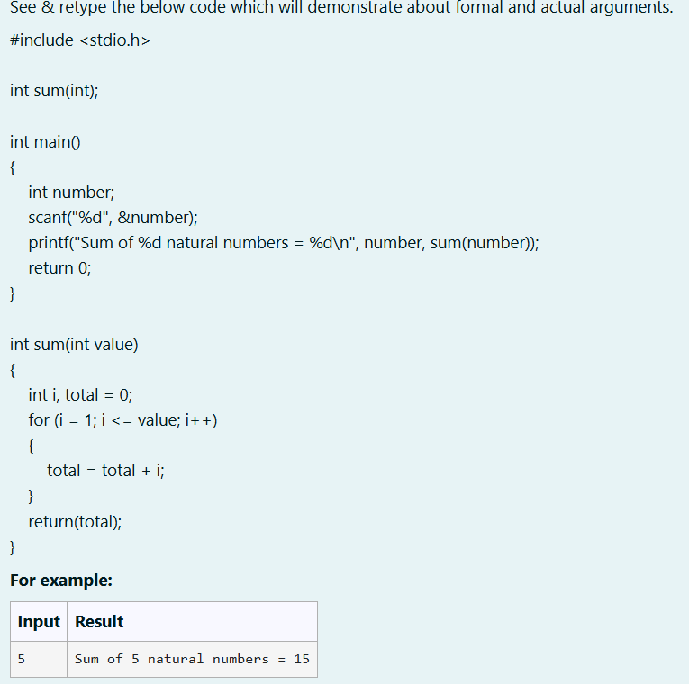

**CODING**

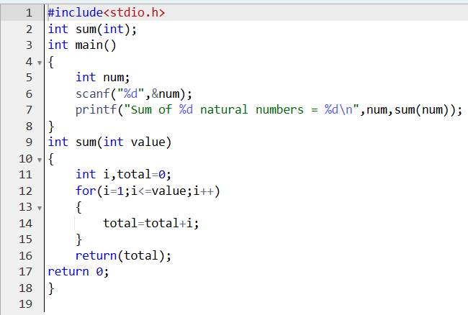

**OUTPUT**

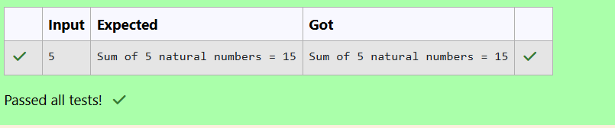

1. **PROBLEM STATEMENT**

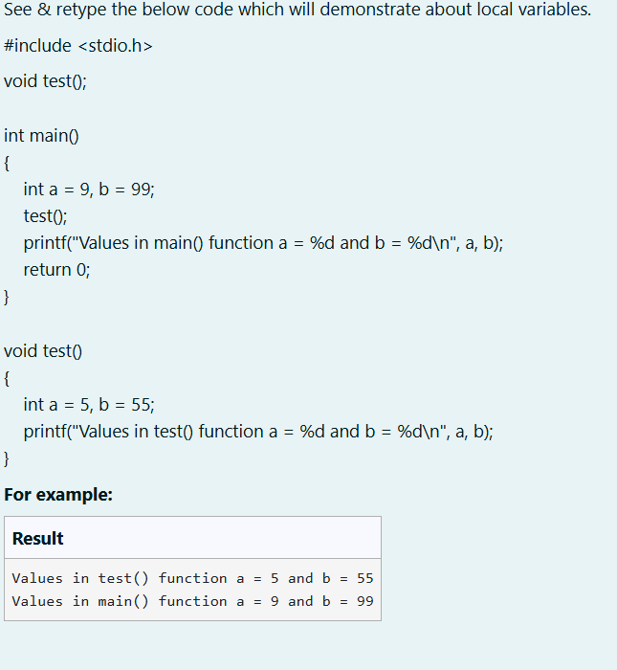

**CODING**

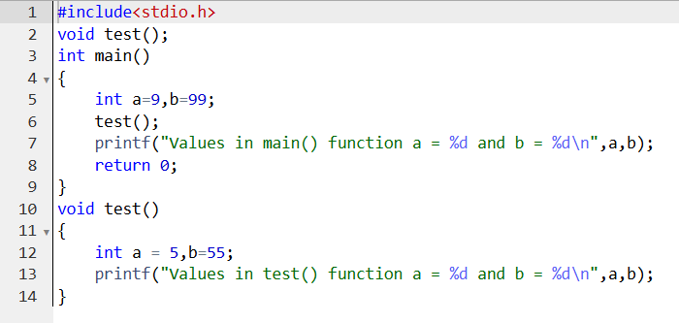

**OUTPUT**

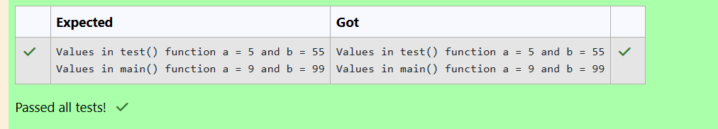

1. **PROBLEM STATEMENT**

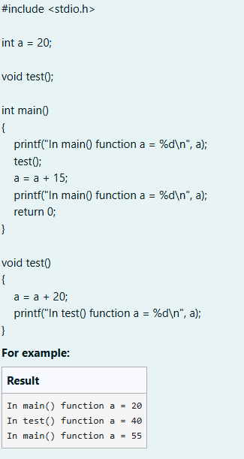

**CODING**

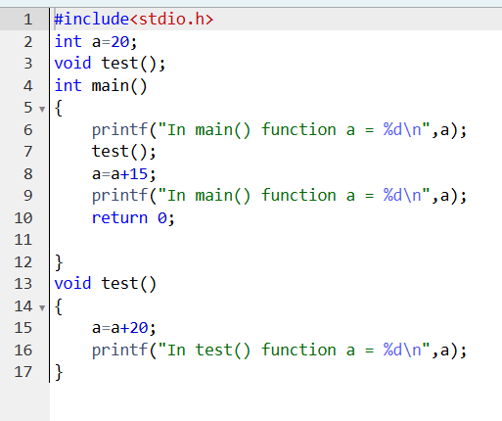

**OUTPUT**

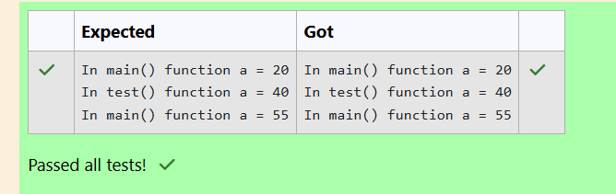

1. **PROBLEM STATEMENT**

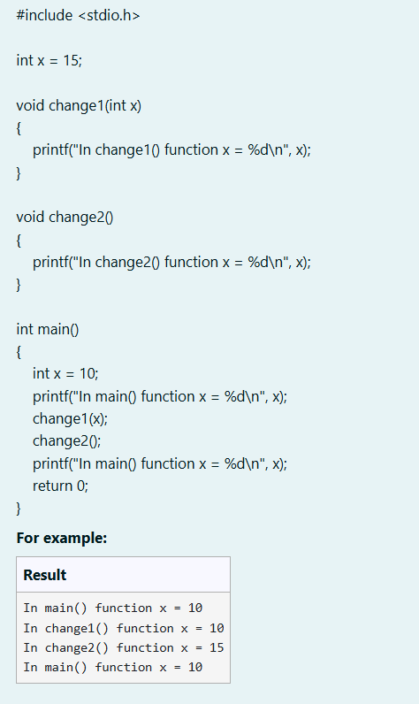

**CODING**

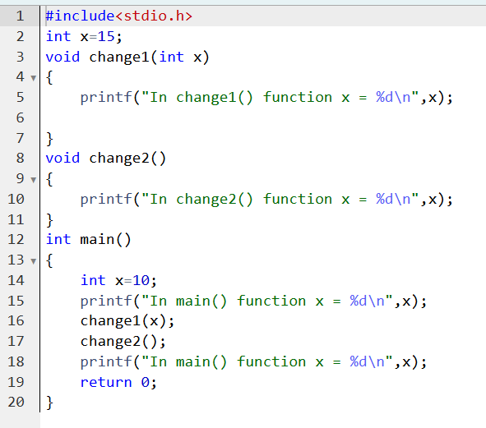

**OUTPUT**

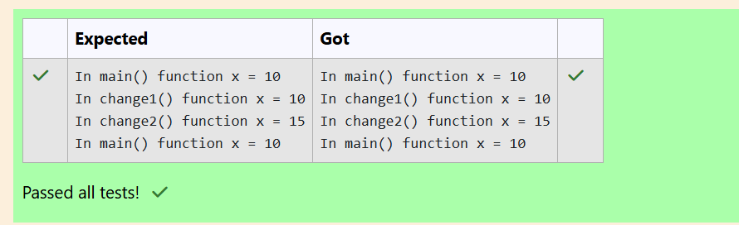

1. **PROBLEM STATEMENT**

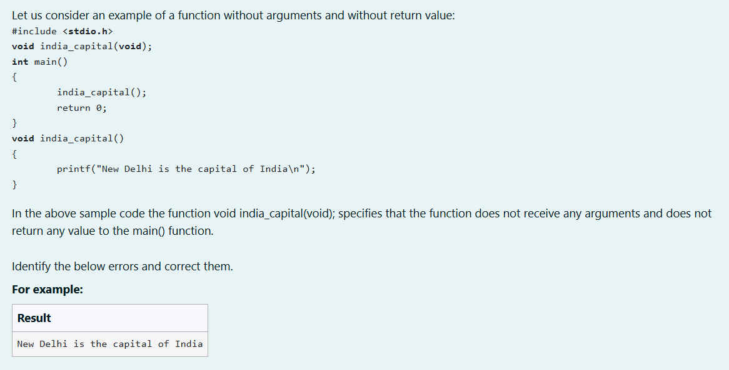

**CODING**

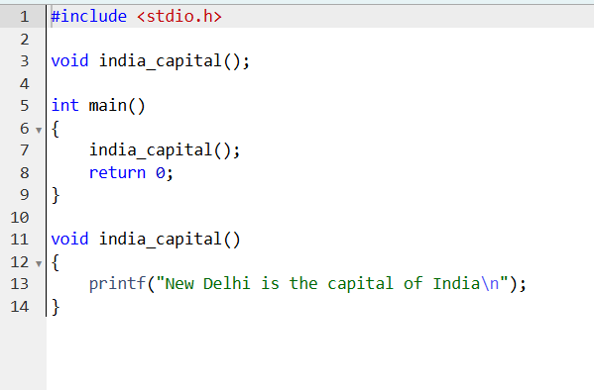

**OUTPUT**

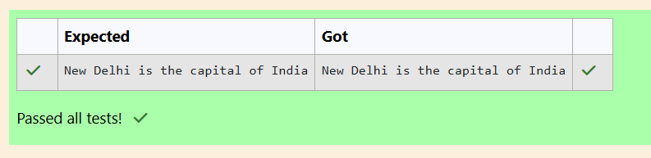

1. **PROBLEM STATEMENT**

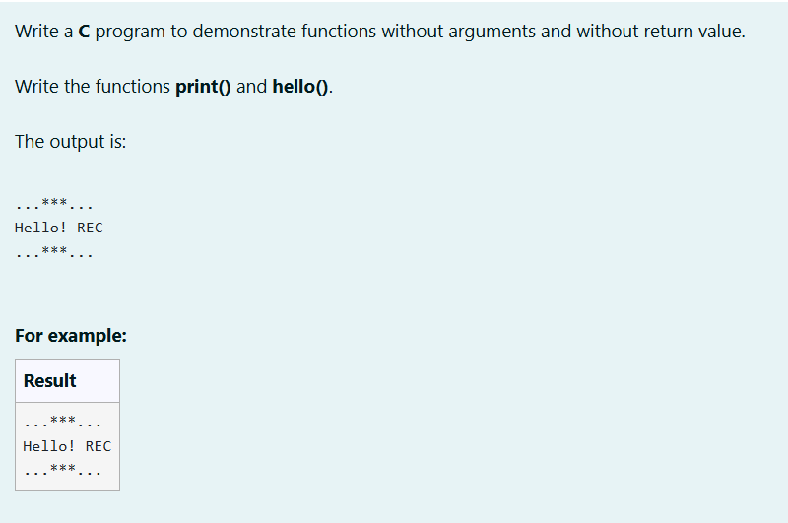

**CODING**

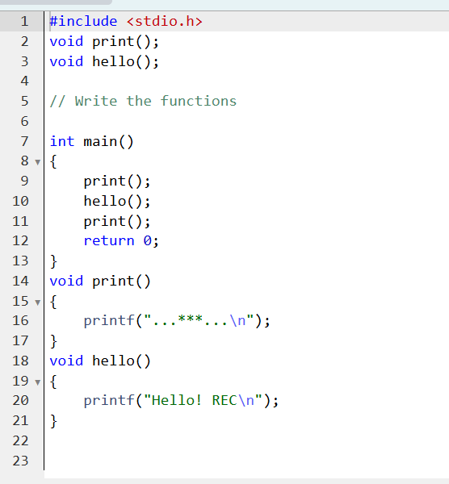

**OUTPUT**

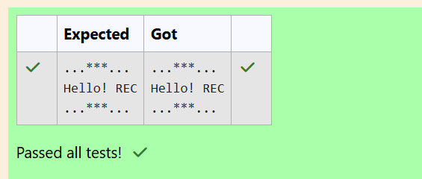

**11.PROBLEM STATEMENT**

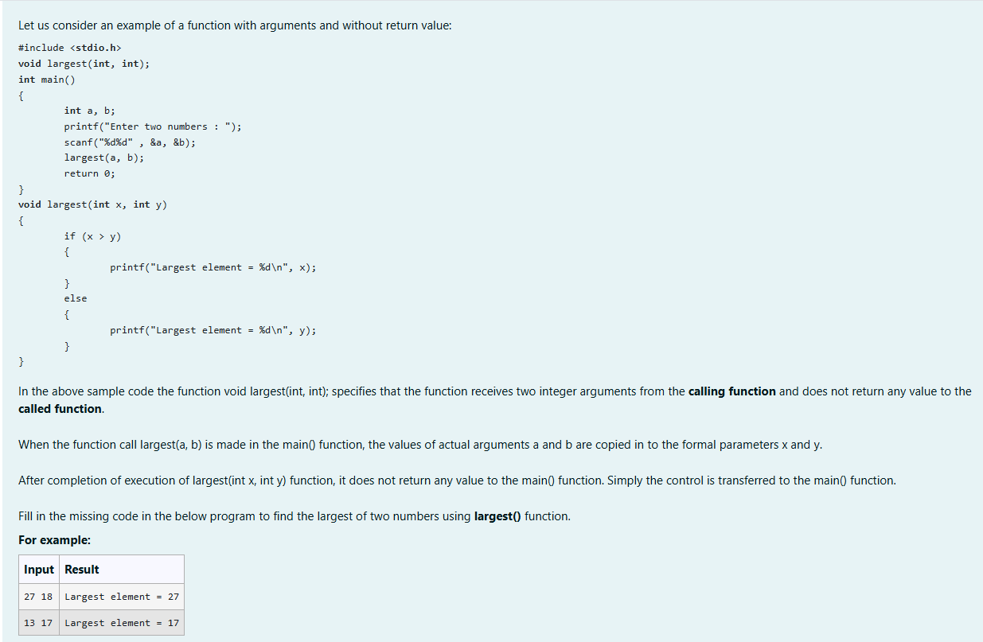

**CODING**

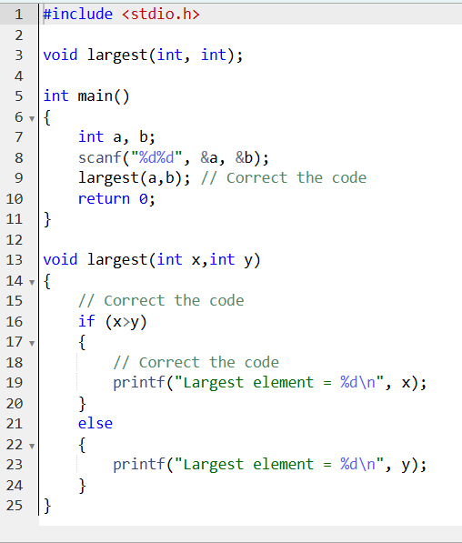

**OUTPUT**

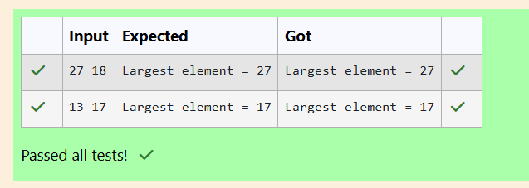

**12. PROBLEM STATEMENT**

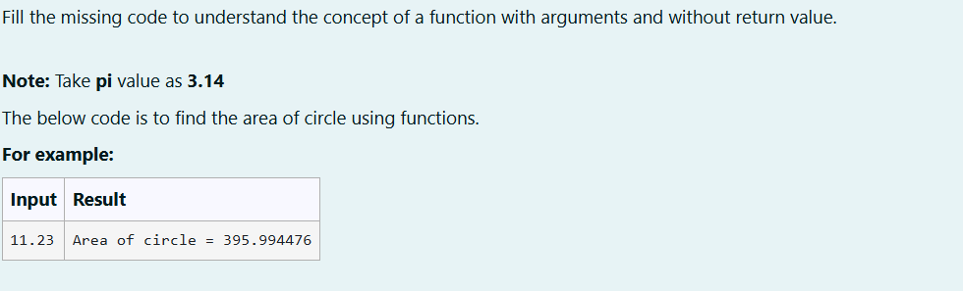

**CODING**

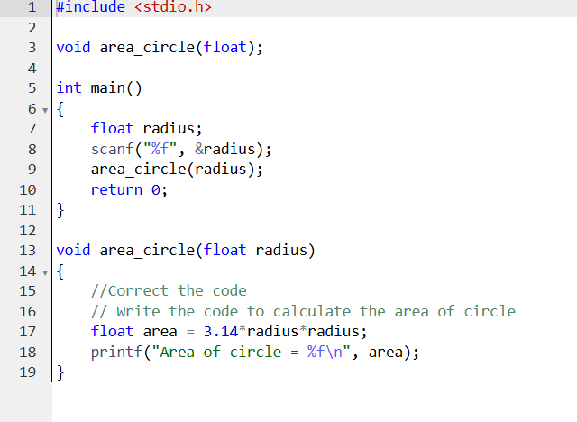

**OUTPUT**

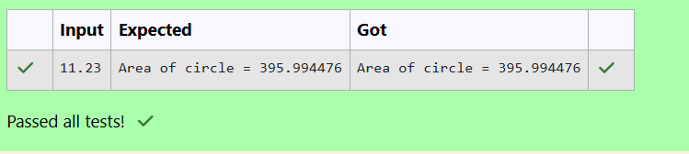

**13. PROBLEM STATEMENT**

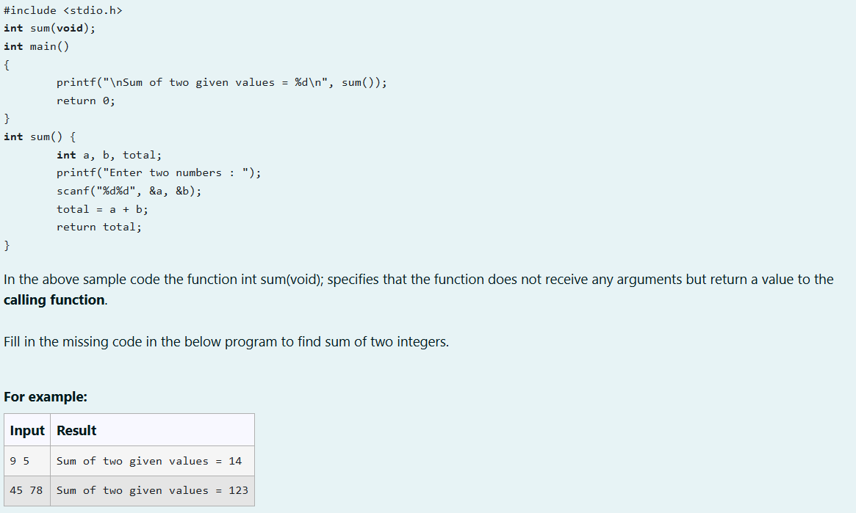

**CODING**

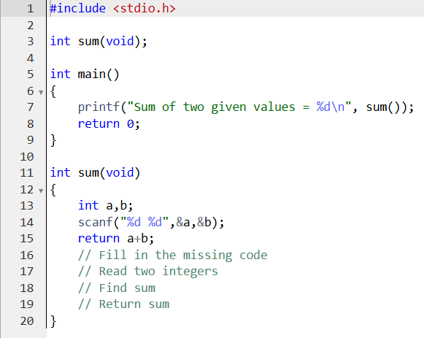

**OUTPUT**

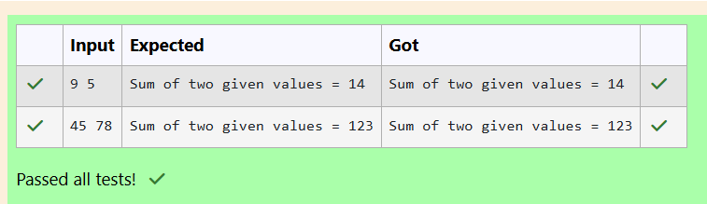

**14. PROBLEM STATEMENT**

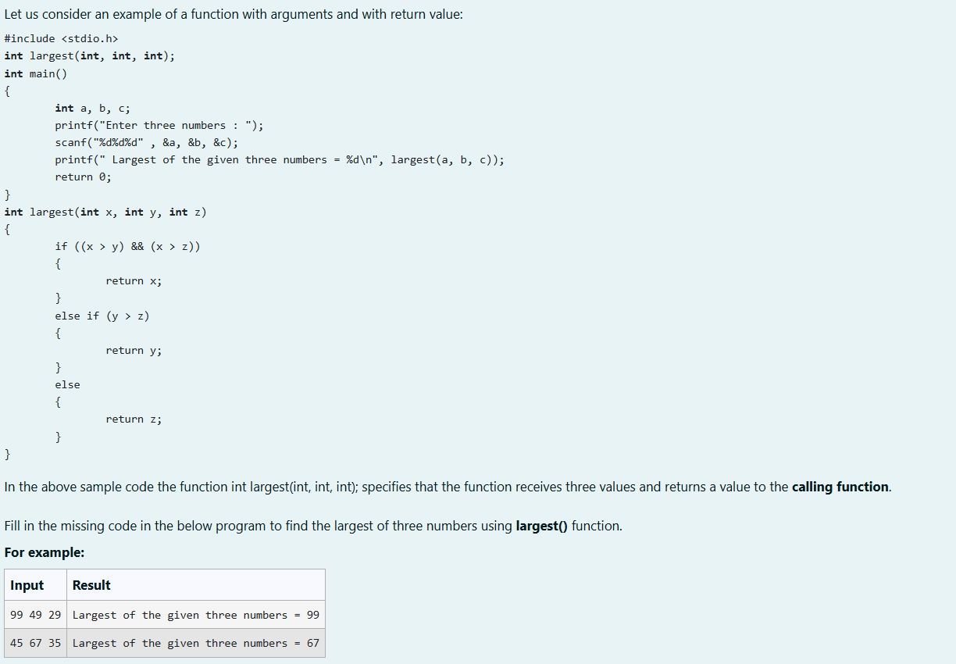

**CODING**

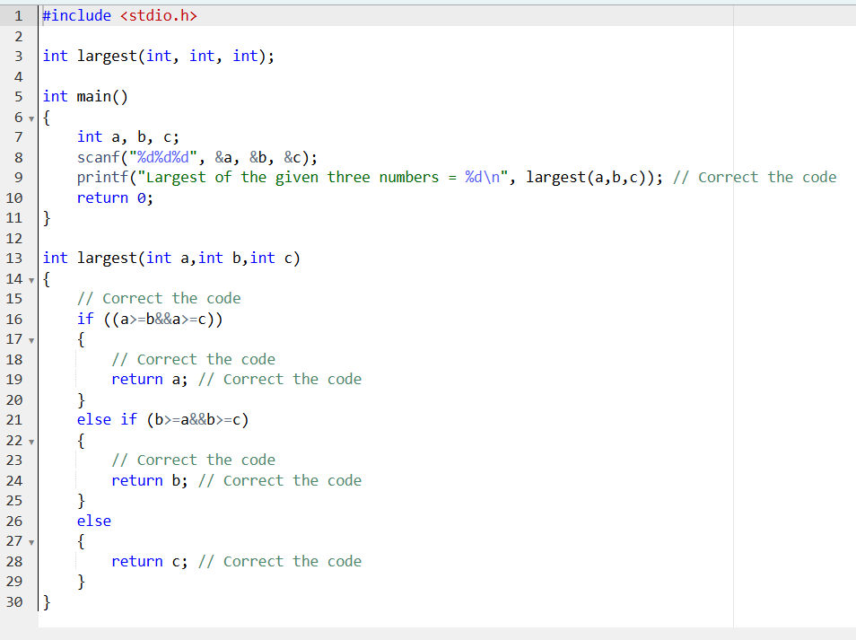

**OUTPUT**

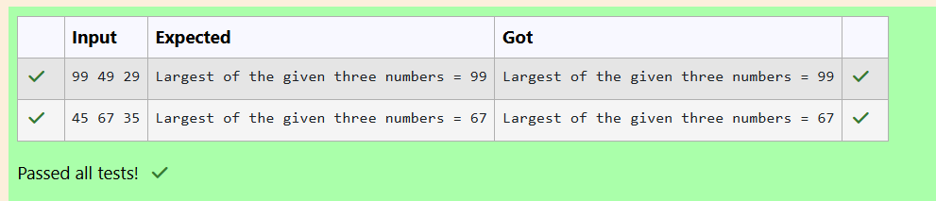

**15. PROBLEM STATEMENT**

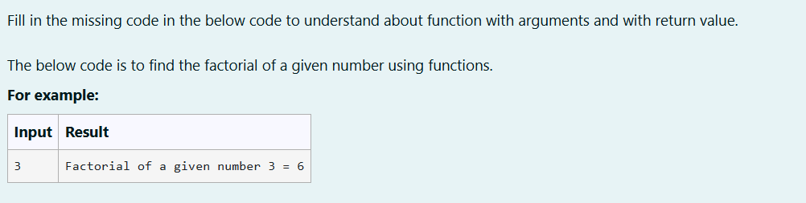

**CODING**

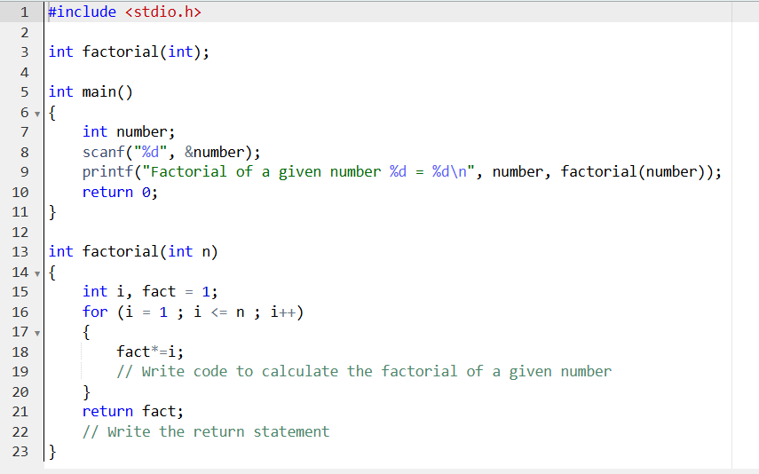

**OUTPUT**

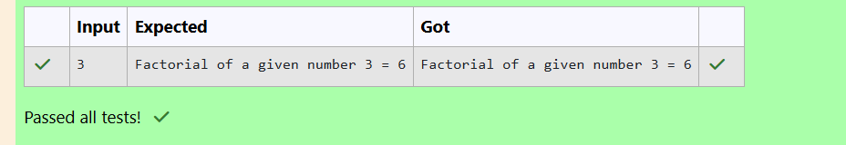

**16. PROBLEM STATEMENT**

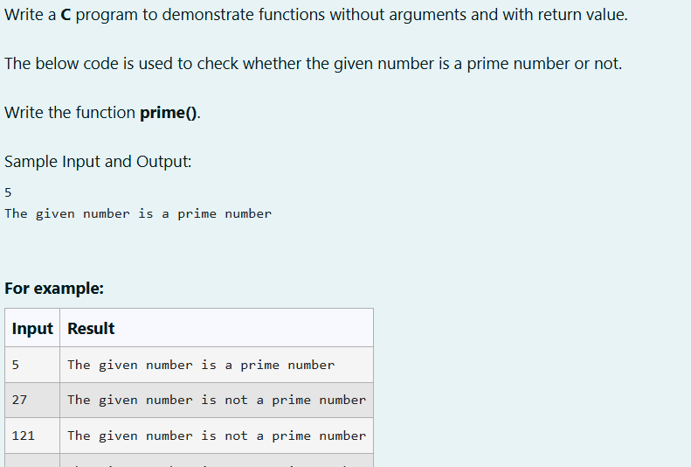

**CODING**

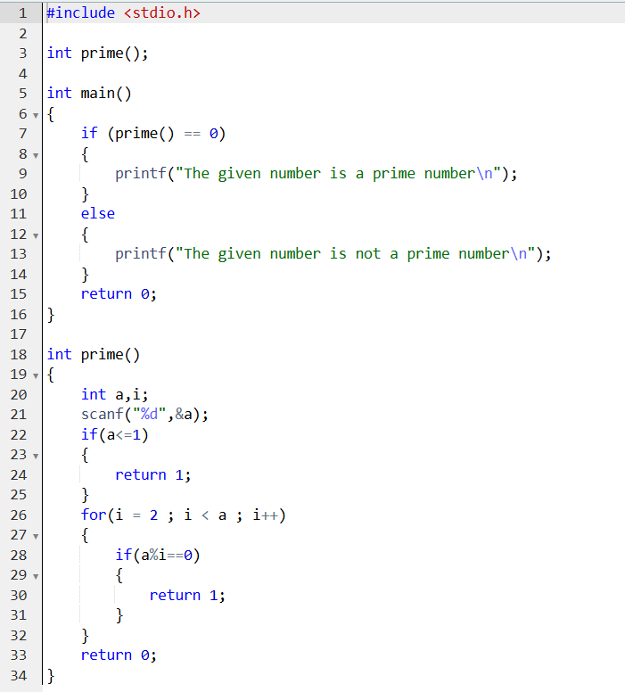

**OUTPUT**

